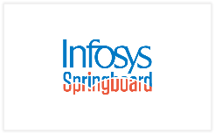
Infosys Springboard Internship 5.0

Title: Project Documentation:

NSEBot Automated Report Retrieval

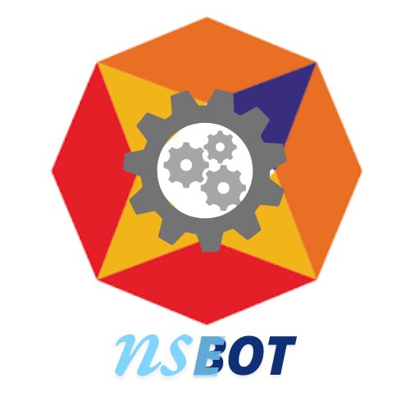

Submitted By : K HEMANTH

•Introduction:
The NSE Reports Downloader is an automated web scraping and report downloading tool designed to interact with the National Stock Exchange (NSE) of India's website. This tool aims to simplify and automate the process of downloading various financial reports published by NSE on a daily basis. The project leverages Selenium WebDriver for web automation, Streamlit for the user interface, and Python for the backend logic.

•Objectives:
- Efficiency: Automate the daily retrieval of reports to save time and effort.
- Accuracy: Ensure consistent and error-free downloading of reports.
- Scalability: Provide a reusable framework adaptable to other data sources or report formats.
- Automation: Minimize manual tasks, reducing operational workload.

•Project Scope:

- Included:
  - Secure data retrieval from NSE servers.
  - Duplicate handling to prevent data redundancy.
  - Validation of reports for CSV format consistency.
  - Automatic redownloading of failed downloads.
  - Organized report management with notifications.

- Excluded:
  - Advanced analytics or processing of the retrieved reports.
  - Integration with third-party financial analysis tools.
  - Retrieval of non-daily reports.

- Constraints:
  - Reliance on the availability and responsiveness of the NSE server.
  - The bot is designed for use within specific operating systems and browsers supported by Selenium.

•Requirements:
- Functional Requirements:
  - Securely connect to the NSE server.
  - Retrieve and validate daily reports in CSV format.
  - Detect and manage duplicate reports by renaming .
  - Log all activities and errors for transparency.
  - Notify users of the download status and errors.
- Non-Functional Requirements:
  - Ensure consistent performance under varying network conditions.
  - Maintain a user-friendly interface for report retrieval.
  - Provide detailed logs for troubleshooting and audit purposes.

•Additional User Stories:

- Report Organization
  - As a user, I want the system to download, extract, and systematically organize the reports
  - So that I can easily locate and access the files without confusion.
- Email Notifications
  - As a user, I want to receive an email notification after the download process is completed
  - So that I am promptly informed about whether the operation was successful or if any errors occurred.

•Technical Stack:
- Programming Languages: Python
- Frameworks/Libraries:
Selenium, Streamlit,Smtplib etc,
- Databases: Not required (initial version)
- Tools/Platforms:
VS Code , Chrome, Chrome Webdriver, Git/GitHub , Streamlit for UI

•Architecture/Design:
System Architecture:

- User Input Layer: Users schedule download time and provide an email address via the Streamlit UI.
- Scheduler: Uses the schedule library to trigger the download at a specified time.
- Scraper: Selenium automates the interaction with the NSE website to select and download reports.
- File Management: Extracts, organizes, and classifies files based on format.
- Notification System: Sends a status email after completion.

•UML Diagram:

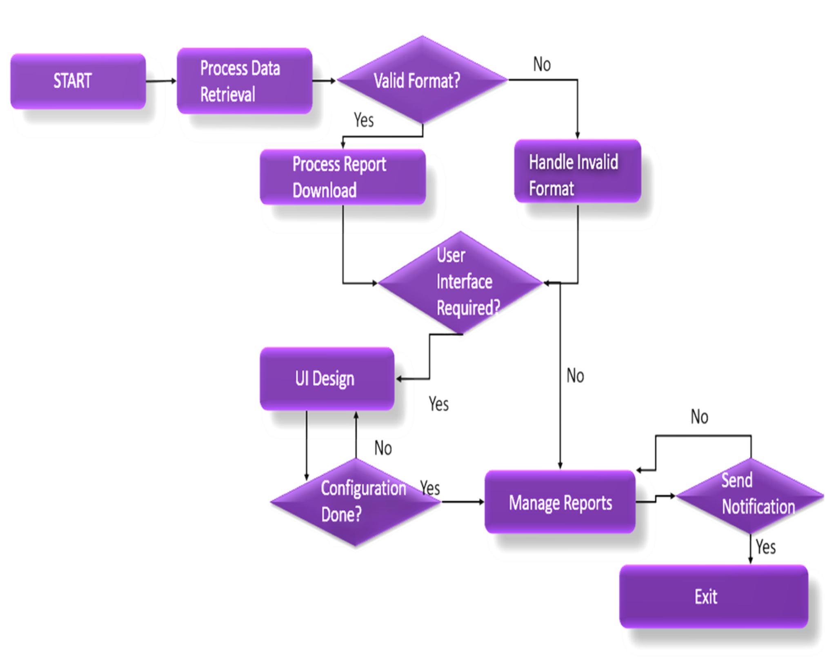

•Development:
- Technologies and Frameworks:
  - Selenium for robust automation of web tasks.
  - Streamlit for developing a user-friendly interface.
  - Smtplib for sending the notifications to user mail id.
- Coding Standards:
  - Followed PEP 8 for Python coding standards.
  - Modular code structure for ease of maintenance.

- Challenges:
  - Handling NSE server timeouts and retries.
  - Ensuring accurate duplicate detection without overwriting.

•Testing:

- Testing Approach:
  - Unit tests for individual modules.
  - Integration tests for end-to-end report retrieval and management.
  - System tests to evaluate performance under realistic conditions.

- Results:
  - Identified and resolved issues with duplicate handling logic.
  - Validated error resilience mechanisms under simulated failures

•Deployment :

- Process:
  - Deploy the application locally using Streamlit.
  - Ensure browser drivers are installed and accessible.

- Instructions:
  - Install dependencies using pip install -r requirements.txt.
  - Run the application with streamlit run app.py.

•Conclusion :
The NSEBot successfully achieves its goal of simplifying the report retrieval process for users. It provides a secure, efficient, and user-friendly solution for managing NSE daily reports. Lessons learned include improving server handling for diverse scenarios and optimizing UI responsiveness. Future enhancements could include support for additional report types and integration with data analysis tools.

- Outcomes

- Automated Daily Report Retrieval:
NSEBot successfully automates the download of daily reports from the NSE website, saving manual effort and ensuring timely updates.
- Robust Error Handling:
Implemented retry mechanisms and logging for seamless operation, even during website downtime or network interruptions.
- User-Friendly Execution:
Simplified setup and execution through environment configuration scripts and optional automation with Task Scheduler.
- Scalability and Reusability:
Designed modular code for easy adaptation to other scraping or automation tasks.

- Achievements

- Streamlined Workflow:
Reduced the manual dependency for daily report downloads to near-zero.
- Integration with Existing Tools:
Successfully integrated Selenium with Python scripts for dynamic web scraping.
- Reliability and Accuracy:
Delivered consistent and accurate report downloads without failures.
- Learning Outcomes:
Strengthened skills in Python, Selenium, and automation while solving real-world challenges.

- References:
  - Selenium and Streamlit official documentation.
  - https://www.selenium.dev/selenium/docs/api/py/api.html
  - https://docs.streamlit.io/

